Kenilworth History & Archaeology Society – AGM 2021

Agenda & Information

1 | Welcome and introduction | For information
2 | Minutes of 2020 AGM | For approval
3 | Chairman’s Report | For information
4 | Annual Accounts | For approval
5 | Election of Chairman & Committee | For approval
6 | Date of the next AGM | For information
7 | Any other business

Please ensure that your response is received no later than midnight on Monday 8 February 2021.

You can send your response by email to; agm@khas.co.uk

or by post to: KHAS AGM, Hill Dene, Old Waste Lane,
Balsall Common, Coventry, CV7 7RY.

Please include your name on your response.

Item 1 – Welcome and Introduction

Welcome to the first virtual AGM of Kenilworth History & Archaeology Society! Many things have been very different during the pandemic and our AGM is no exception.

All of the information that would have been presented at an actual AGM is contained within this document and its attachments. Please enjoy reading about what has taken place through the year, but most importantly, please vote on the items that are for approval, which are:

- Item 2 – last year’s AGM minutes
- Item 4 – the 2019-20 accounts and appointment of auditor
- Item 5 – election of Chairman and Committee

On each of the above items please submit your vote for, against or abstain.

To register your votes please reply to the covering email with the item number (namely 2,4 & 5) and whether you are for / against / abstaining on that item and include your name.

Alternatively you can submit the same information in writing and send it to KHAS AGM, Hill Dene, Old Waste Lane, Balsall common, CV7 7RY.

The closing date for receipt of responses will be midnight on Monday 8 February 2021. Any responses received after this date will not be included.

After the closing date the responses to voting will be collated, along with questions and comments from members and these will be circulated to the membership.

Item 2 – Minutes of the previous AGM

The minutes of the previous AGM, which was held on 10 February 2020, are on the following pages:

The proposal is: to approve the minutes of the AGM held on 10 February 2020.

Minutes of the Annual General Meeting of Kenilworth History & Archaeology Society, held on Monday 10th February 2020 at 7.45pm in the Senior Citizens’ Club, Kenilworth
The meeting was chaired by the Society’s Chairman, Jan Cooper
1. Apologies:
Apologies were received from Roz Comins, Michael Male, Graham Earle and Christine Smee.
2. Minutes of the Annual General Meeting held on Monday 11th February 2019:
Members each had a printed copy. The Minutes were adopted by the meeting on a proposal from Nick Green, seconded by Sylvia Wilde, and subsequently signed by the Chairman.
3. Matters arising from the Minutes:
Michael Poole referred to the matter of Leamington History Fair that he had raised under AOB in 2019. The Chairman confirmed that KHAS had not been invited to attend. If invited, attendance would only be possible if some new volunteers would be prepared to undertake it.
4. Chairman’s Report:
The Chairman referred members to her full report in Kenilworth History 2020. She had been pleased to welcome several new members during the year, and commented that it was good to see new faces and to receive fresh feedback. She expressed the hope that the programme of meetings had been enjoyed, and stressed that new suggestions for talks were always welcomed from members.
The re-roofing of the Barn had caused the usual Easter opening to be delayed, but was completed in time for the next Bank Holiday. The question was often asked as to why the Barn was not open more often, to which the answer was “lack of volunteers”. Members were urged to contact Margaret Kane or Michael Formstone and sign up as Barn volunteers, even if only for a single afternoon in the summer.
2019 had marked the 900th anniversary of the foundation of the Priory, and this had generated a lot of local interest. The Christmas meeting had been very much enjoyed by those who attended, but the turnout had been rather low.

5. Treasurer’s Report:
Members each had a printed copy of the audited accounts for the year ended 30th November 2019. The Treasurer thanked Richard Gillard for his work in auditing the Accounts.
There was a deficit for the year of £538.93, which was partly due to an amount of £230 having been spent on equipment at the Barn to enable the new Kenilworth Castle representation to be displayed. The cost of room hire had increased from £300 to £360, and the printing of Kenilworth History 2019 by a new supplier had been more expensive, the local printer used previously having ceased trading. A cheaper printing company had been found for Kenilworth History 2020.
Because the deficit in 2019 was due to exceptional items, it had been resolved that membership subscriptions should remain at the same level as last year.
The Accounts, and the appointment of Richard Gillard as Auditor, were formally adopted by the meeting on a proposal from Hanne Manning, seconded by Steven Wallsgrove and confirmed by the meeting.
6. Election of Officers:
The Chairman reported that no nominations had been received to replace Geoff Whiteman, the retiring Secretary, and it was proposed that, at least in the short term, some of the other Committee members would share some of the responsibilities of Secretary. A requirement remained to recruit a Minutes Secretary as soon as possible, and the Chairman appealed for someone to come forward and help with that position. Apart from the Secretary, all of the other officers and committee members had indicated their willingness to serve for a further term, and no other nominations had been received by the closing date of 27th January. It was moved that the Committee should continue as described above, on a proposal by Mike Formstone, seconded by Barbara Platten and adopted by the meeting. The Committee for 2020 is therefore as follows:
Chairman – Jan Cooper
Vice-Chairman – Norman Stevens
Webmaster – Chris Blunt
Treasurer – Anthony Manning
Minutes Secretary – currently vacant
Committee Members – Margaret Kane, Philip Stock, Susan Martin

7. Date of the next AGM:
The next AGM will be held on Monday 8th February 2021.
8. Any Other Business:
An email had been received from the Treasurer of Kenilworth Family History Society asking if we had been consulted about the increase in evening car parking charges to £1.50, and whether KHAS would be prepared to support a request for a reduced rate to apply to parking between 6pm and 10pm. The Chairman confirmed that we had not been consulted and asked for a show of hands to indicate the level of support for a reduced evening charge. Agreement was unanimous, and the Chairman undertook to reply to the KFHS Treasurer accordingly, expressing our very strong support for a lower evening tariff.
The Chairman referred to the fact that Geoff Whiteman was standing down as Secretary after seven years in the post. She thanked him for the work he had done over that period, and invited the meeting to join her in an expression of appreciation, which was followed by a round of applause.
There being no further business, the meeting closed at 8.00pm.

Item 3 – Chairman’s Report

This year has been a very difficult, and in some cases tragic, year for many people.
We had three meetings at the beginning of 2020. In January Graham Sutherland entertained us with details of “the Darker Side of Warwick”; following our AGM in February our fellow member David Morse spoke about “St. Paul’s Watch” – a fascinating and personal family account of the role of the Civil Defence organisation in caring for St. Paul’s, London, during WW2 and in March we had a welcome return of Stephen Spinks who gave an account of the colourful and turbulent life of Robert the Bruce, following the publication of his latest biography. At the end of that last evening, as we all dispersed in happy mood and looking forward to our April meeting, we had no idea of what was to come! As the country went into Covid lockdown it soon became clear that our meetings would have to be cancelled until autumn. That hope was clearly overly optimistic and we then had to cancel the remainder of the year with a view to restarting in January 2021. Now we look to April 2021 in the hope that the new vaccines will help us finally to get to grips with this terrible pandemic. I am pleased to be able to tell you that all of our speakers and summer visits have been rescheduled for 2021.
Despite there being no meetings since March I have been delighted to “welcome” 7 new members and will look forward finally to getting to meet them in person next year.
Throughout the year your Committee has worked hard cancelling and rebooking speakers and visits and sending out information which we hoped you would find helpful and interesting. I do hope that some of you managed to join a few of the many interesting on- line lectures offered by the CBA Festival of Archaeology, the Warwickshire Local History Society and the Battlefields Trust, amongst others.
Sadly we have been unable to open our Museum at all this year. Even during July and August, when technically it would have been permissible, the fact that there is only one door for both entry and exit, and limited space on both floors and staircase, it was felt that social distancing simply would not have been possible to control. Additionally, many of us who volunteer to help are ‘of a certain age’ and would perhaps have felt uncomfortable in such an enclosed space. Everyone’s safety had to be paramount.
In September “The Antiques Road Show” team came to Kenilworth and spent two days filming at the castle. Numbers attending were strictly limited to accommodate social distancing but the sun shone and our castle looked stunning as ever. Watch out for details of when the new series will be shown on television!
As I write “Kenilworth History 2021” is almost complete and will be distributed to all members in February following our AGM which will, of course, need to be conducted via e- mail/post. Thank you to all of you who have continued to support KHAS and I sincerely hope that those members who were unable to renew their subscriptions at the beginning of the year will do so for 2021. I very much look forward to seeing you all again just as soon as ever possible.
With very best wishes to you all for a safe, healthy and happy New Year.
Jan Cooper, December 2020

Item 4 – Treasurer’s Report

The balance sheet for 2020 and the comparison sheet for 2019 – 2020 are on the following pages.

The proposal is: To approve the accounts as presented for the year 2019 – 2020, and to appoint Richard Gillard as auditor for the 2020 – 2021 accounts.

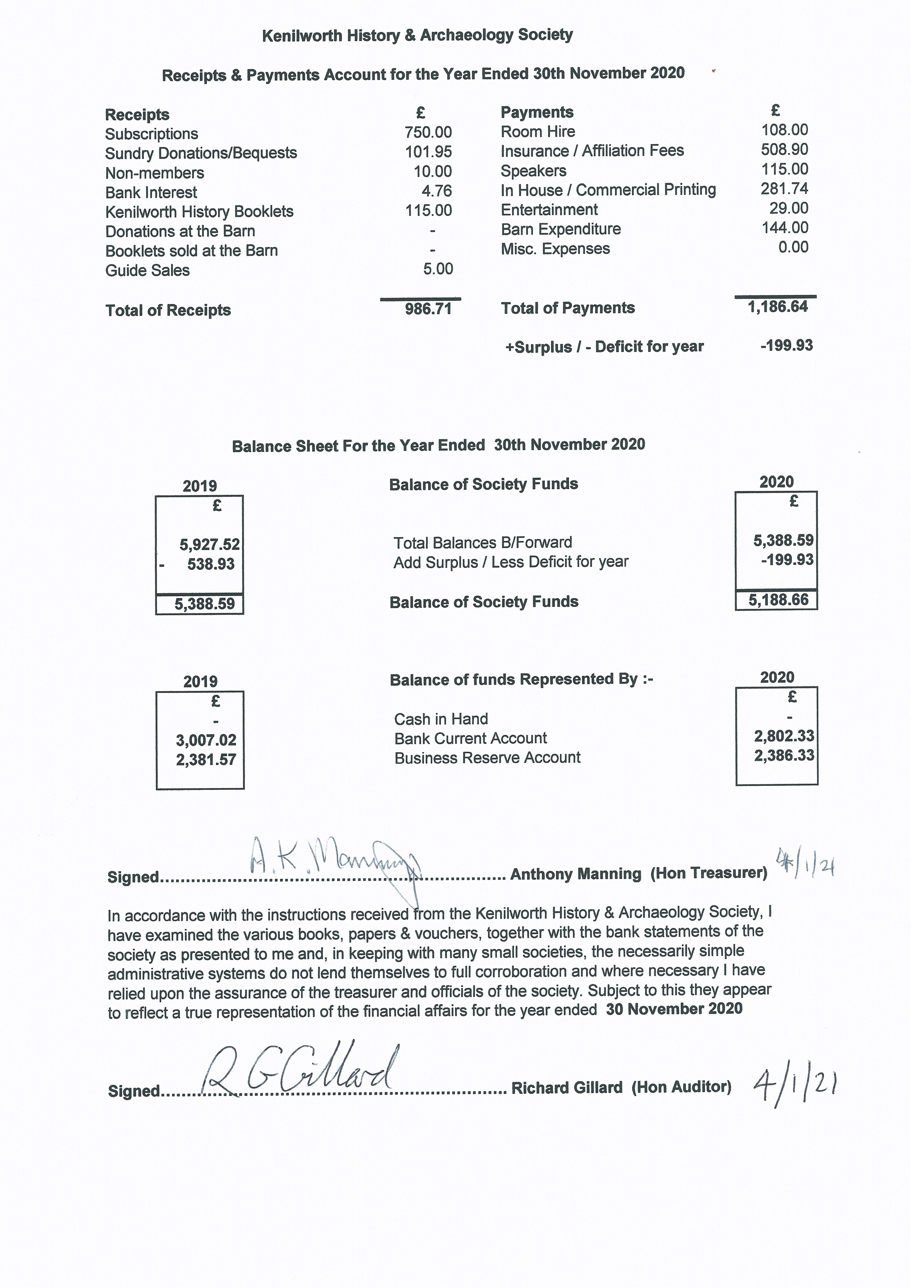

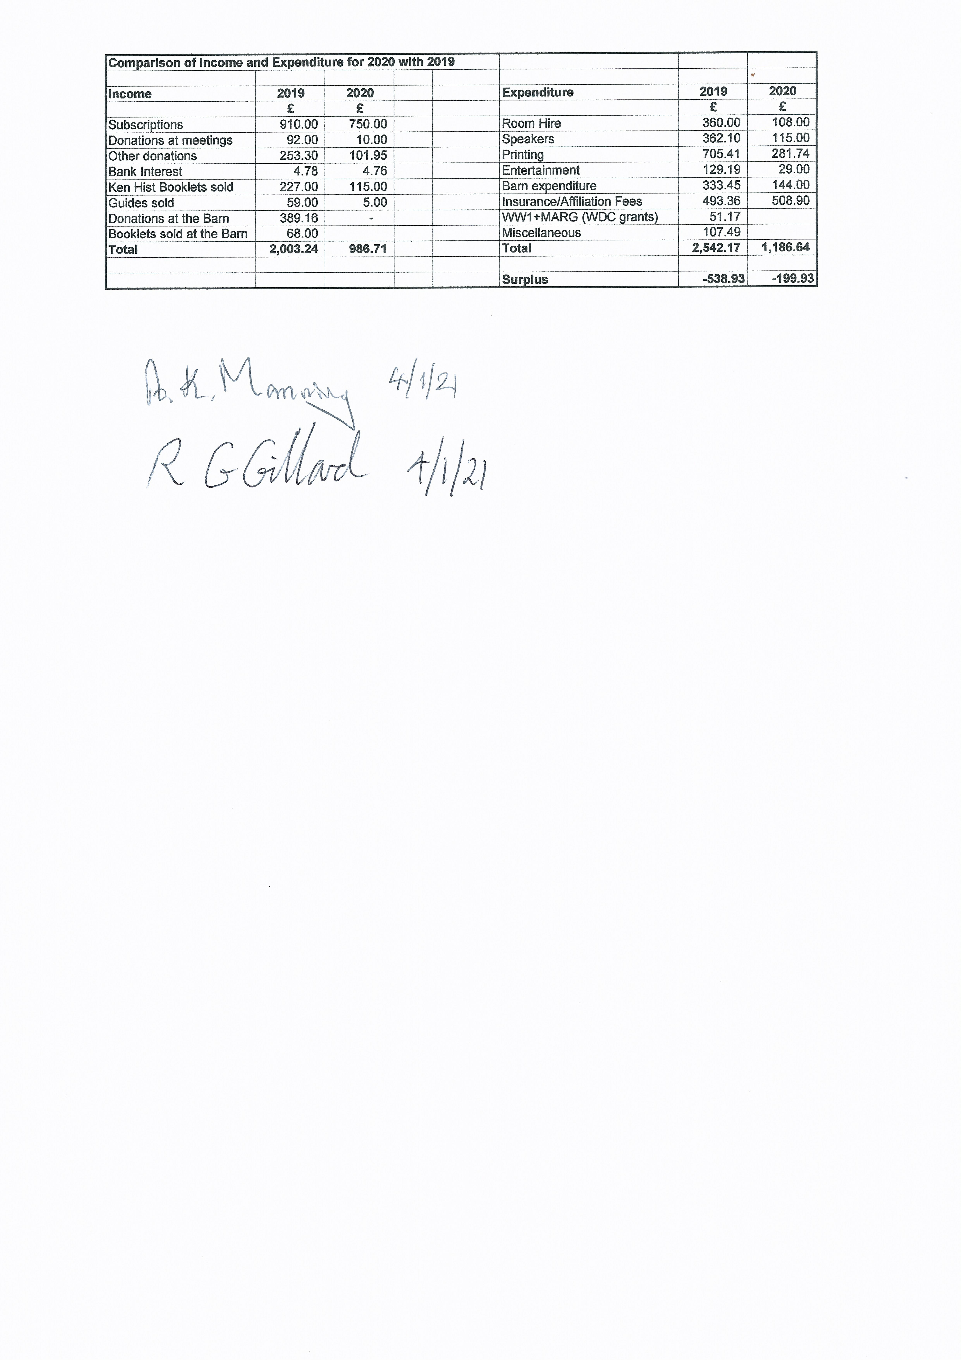

Item 5 – Election of Chairman & Committee

The KHAS Constitution allows for a committee eight people comprising five Officers being Chairman, Deputy Chairman, Treasurer, Secretary, Webmaster, plus three committee members.

There are currently only seven people on the Committee, all of whom are prepared to be re-elected:

Chairman: Jan Cooper
Deputy Chairman: Norman Stevens
Treasurer: Anthony Manning
Webmaster: Chris Blunt
Member: Margaret Kane
Member: Phil Stock
Member: Sue Martin

The position of Secretary is currently vacant.

Regrettably, no nominations have been received for the position of Secretary.

The proposal is: Jan Cooper is re-elected as Chairman and that the other six committee members are re-elected to form the Committee for 2021 - 2022.

Item 6 – Date of the next AGM

The next AGM will be on Monday 14 February 2022.

Item 7 – Any Other Business

You are invited to submit any questions or comments relating to these AGM documents or about Kenilworth History & Archaeology Society in general.

Questions and comments that are received, and the responses, will be shared with the membership in the minutes of this meeting along with the name of who has submitted the question or comment.

